USER MANUAL
To use the program, you just have to open the executable file Source_Code.exe located in the /dist folder. Do not move the file out of this folder. Do not delete the pkl files either.

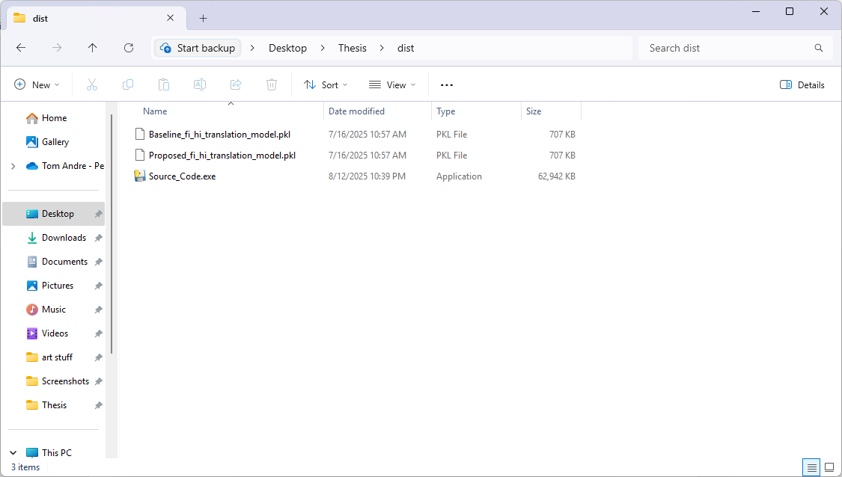
This is the User Interface:
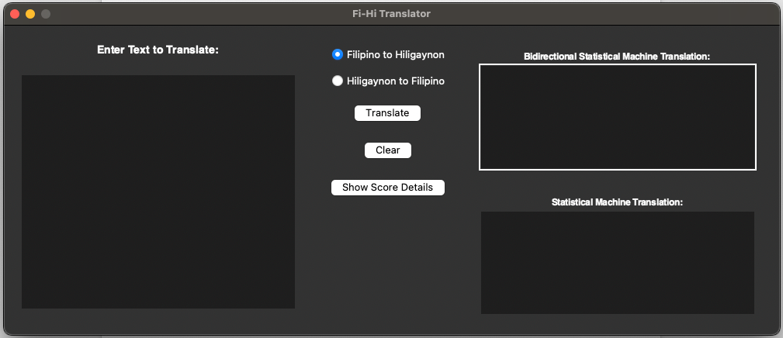

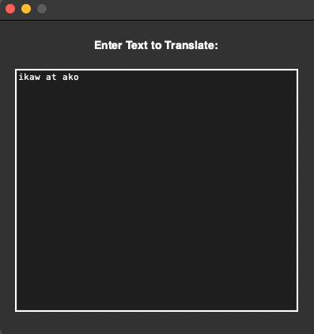
Enter the words on this text box

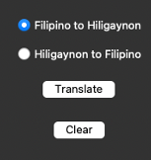
Select the desired language to translate and then click the Translate button

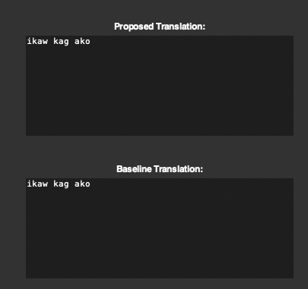
The translation will be displayed on this area of the program. It can be copied and paste to a text file
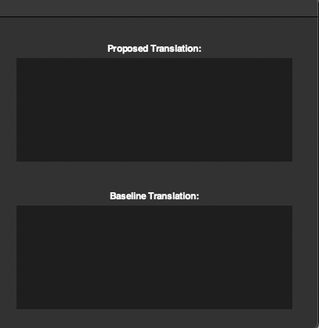
Click the Clear button to clear out the translation text boxes

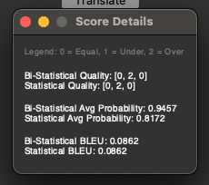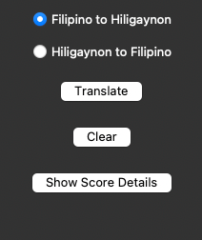
Click the Show Score details to display the scores in terms of Quality, Probability and BLEU.

